

2023 - Spring
Introduction to Leadership & Management for Engineers
Midterm

Name & Surname: Nurullah Said Tüğmen
ID: 150720823

Q1: Which leadership theory do you see in Billy’s leadership approach & what makes you think so?


The main character of "Moneyball," Billy Beane, uses a leadership style that aligns with several leadership theories. One of these theories is transformational leadership, where the leader inspires and motivates their followers to achieve their full potential by creating a vision for the future and empowering them to achieve it. Billy demonstrates this by challenging traditional methods and using data-driven analysis to build a winning baseball team.
Another theory evident in Billy's approach is situational leadership, where the leader adapts their style to the needs of their followers and the situation at hand. Billy shows empathy and support for struggling players and challenges underperforming ones.
Additionally, contingency theory is present in Billy's leadership approach, which suggests that leadership effectiveness depends on the fit between the leader's style and the demands of the situation. Billy adapts his leadership approach by using data-driven analysis to identify undervalued players who can contribute to the team's success.
Overall, Billy Beane's leadership approach in "Moneyball" combines elements of transformational, situational, and contingency theories. He inspires and motivates his followers, adapts his leadership style to the situation and individual needs of his players, and uses data-driven analysis to build a successful team.

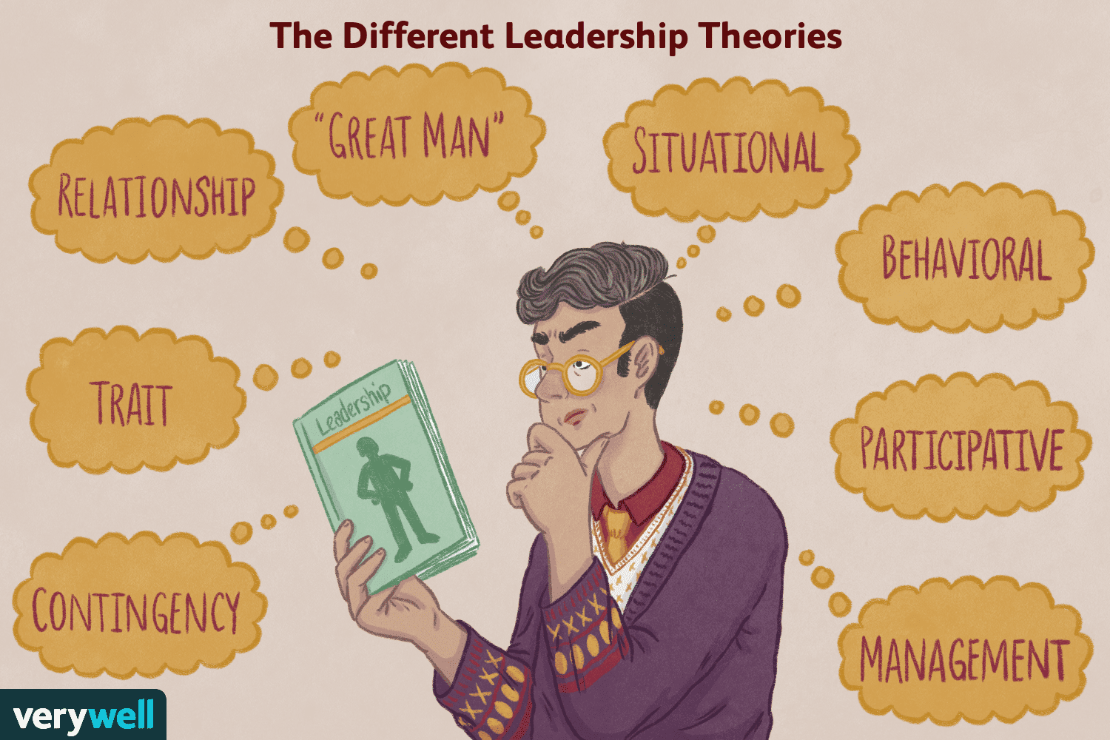

Q2: How do you describe Billy’s leadership mistakes?

- In terms of 3 basic needs
To meet the need for survival, it's important for a leader like Billy to consider both statistical analysis and the human factors that impact the team's success. Billy's mistake was not considering the impact of letting go of key players on the team's morale and cohesion. This could have put the team's survival at risk. Additionally, he didn't prioritize the psychological and emotional needs of his players, which are important for their overall well-being and performance. This lack of consideration could have also endangered the team's survival.


Regarding the need for purpose, Billy's leadership mistake was his narrow focus on statistical analysis and undervaluing the importance of teamwork. By solely focusing on acquiring players with specific skills, Billy neglected to consider how those skills fit within the team and contributed to its overall success. This could lead to a lack of cohesion, motivation, and engagement among players. Moreover, his tendency to micromanage the team's performance can limit players' growth and development, hindering their sense of purpose within the team.

In terms of the need for esteem, Billy's leadership mistake was his lack of emotional intelligence and empathy towards his players. His sole focus on data and analytics made him appear cold and unfeeling, hindering his ability to build trust and create a positive team culture. This lack of connection can make it difficult for him to understand the perspectives and emotions of his players, resulting in missed opportunities for motivating and inspiring them. Ultimately, this failure to cultivate a positive team environment hindered the potential of the team.

- In terms of EQ
Emotional intelligence (EQ) refers to the ability to recognize, understand, and manage one's own emotions as well as those of others. Billy Beane's leadership mistakes in the movie "Moneyball" can be described in terms of EQ in the following ways:

Empathy:
Billy struggles to understand the emotions and perspectives of others, which makes it challenging for him to connect with his players and build strong relationships with them. In the movie, Billy's lack of empathy is evident in his focus on data and analytics while ignoring the human aspect of the game. He fails to recognize that his players are more than just numbers and that their emotions and feelings can impact their performance on the field.

Self-awareness:
Billy faces difficulty in comprehending his own emotions and how they affect his decision-making process. He often lets his frustration with the team's performance drive him to make hasty decisions that are not always in the best interest of the team. Additionally, Billy's lack of self-awareness can result in a lack of accountability for his actions, which can harm his relationships with his players.

Social skills:

Billy's lack of empathy and connection with his players can lead to a lack of trust and communication, which can adversely affect the team's performance. Moreover, his communication style can seem curt and dismissive, which can lead to conflicts and damage relationships. In the movie, Billy's leadership mistakes in terms of social skills include his failure to effectively communicate his vision and strategy to his team, which can cause confusion and uncertainty among his players.

Q3: Which leadership theory do you recommend Billy to follow & why (as much as concrete & specific)?


My recommendation for Billy Beane, based on the challenges he faces as a leader, is to adopt the Transformational Leadership Theory. This theory suggests that effective leaders motivate their followers by providing them with a clear vision, challenging them to improve and grow, and creating a positive and supportive work environment. In the movie, Billy is tasked with transforming a low-budget baseball team into a competitive one. By following the principles of the Transformational Leadership Theory, Billy can motivate his players to reach their full potential and create a positive team culture that emphasizes collaboration and teamwork.
To apply the Transformational Leadership Theory, Billy needs to do the following:
- Inspire and motivate his players by challenging them to improve and grow, providing regular feedback, recognizing their achievements, and offering professional development opportunities.

- Clearly communicate his vision and purpose for the team, outlining specific goals and objectives that each player needs to achieve.

- Create a positive work environment by fostering open communication, encouraging teamwork, treating players with respect and dignity, and promoting team-building activities and events.

By adopting the Transformational Leadership Theory, Billy can build a team culture that fosters collaboration, supports individual growth, and drives the team's success.

